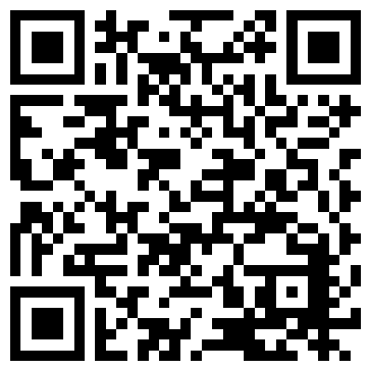
8 Huge PowerPoint Mistakes Checklist
Make sure you watch the video first!
https://www.englishgymjapan.com/8hugepowerpointmistakes
Please check the boxes after you complete making your PowerPoint slideshow.

1. My slides do not have too much writing.
(Each slide with too much writing = -10%.)

2. My slides have no spelling mistakes.
(Each spelling mistake = -10%.)

3. My titles, bullet points, etc. use capital letters appropriately.
(Not using capital letters appropriately = -10%.)

4. My font sizes were big enough, at least 30 point font.
(If the font size is too small = -10%.)

5. My images have no watermarks.
(Each image with a watermark = -10%.)

6. My images are not blurry; they are very high-quality images.
(Blurry, low-quality images = -10%.)

7. My slides have no Japanese; they are all in English.
(Each slide with Japanese = -10%.)

8. My slides do not have too many or crazy, senseless animations.
(Too many, crazy, or senseless animations = -10%.)

9. I have practiced my PowerPoint presentation with a timer.
(Practice makes perfect. You should practice many, many times!)

10. I promise to TALK and NOT READ my presentation.
(If you read, you will not pass!)

Name: Number:

