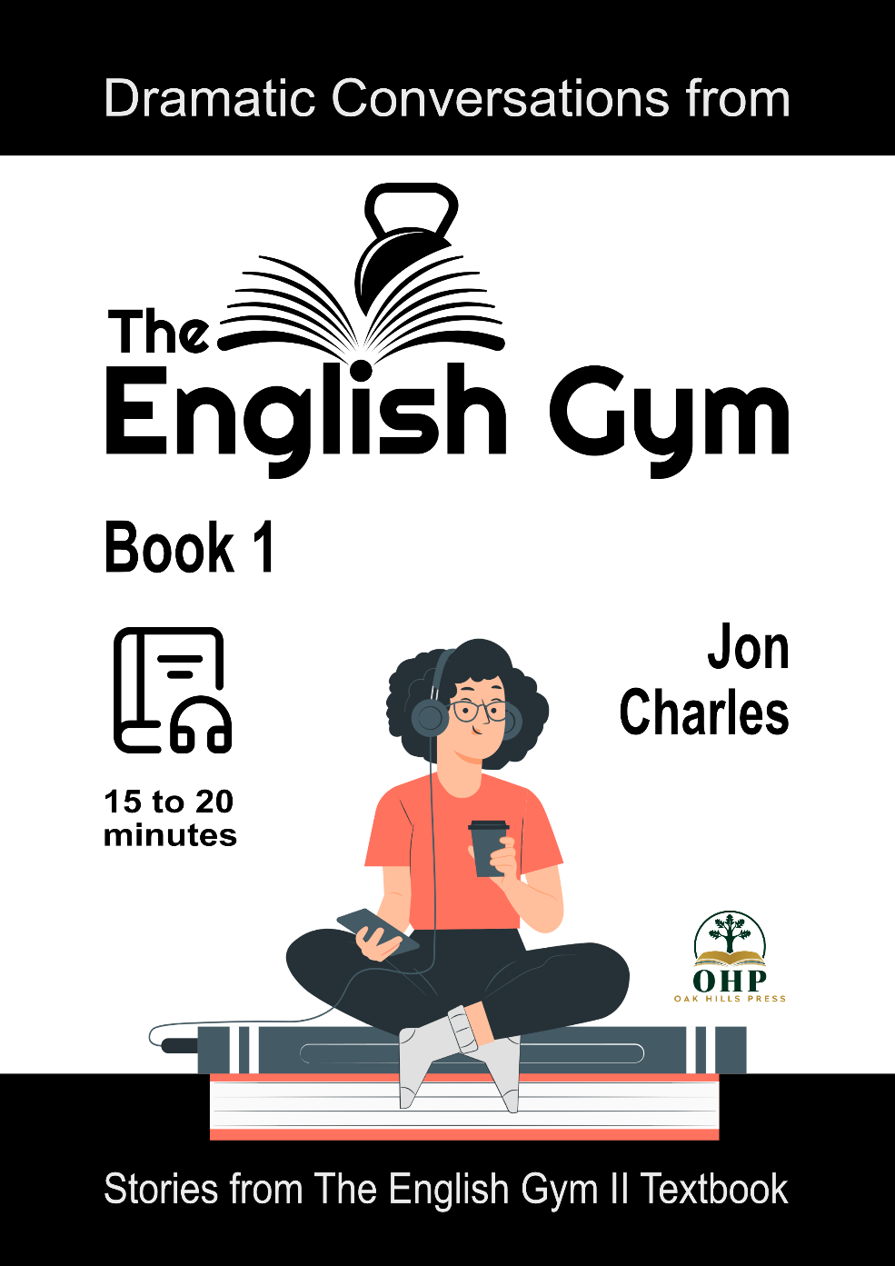
Dramatic conversations from
The English Gym II textbook
by Jon Charles

Book 1
A collection of short dialogues from The English Gym II textbook.
Topics include fast food or healthy food, smartphone addiction, country life or city life, part-time jobs, taking care of the elderly, dating, and the environment.



####
Contents
Introduction
Story 01: Fast Food or Healthy Food?
Story 02: Smartphone Addiction
Story 03: Country Life or City Life?
Story 04: Part-Time Jobs
Story 05: Who Will Take Care of Mom?
Story 06: Too Shy and Too Scared
Story 07: Saving Our Oceans

####
Introduction

All of the stories in this collection include dramatic audio recordings from the textbook, The English Gym II. It is recommended to listen to the audio as you read.

####

Story 01: Fast Food or Healthy Food?

Pre-Reading Vocabulary:
chubby = a little overweight or fat
kale = a very healthy leaf cabbage
*****
Situation:
Two friends are talking about what to have for lunch.

Ronald: Hey, Genki. I’m starving. Why don’t we get some lunch?
Genki: Oh, yeah, sure. Where do you want to go?
R: How about McDonald’s? I could really go for a Big Mac, french fries, a large Coke and maybe an apple pie!
G: McDonald’s?! That’s just junk food, man. We should eat something healthier, like a salad or chicken.
R: Well, they have chicken nuggets and I think they have a salad, but I’ve never ordered one. Or, we could go to KFC, they have lots of chicken!
G: KFC?! Kentucky Fried Chicken! Do you know what fried means? It means deep fried in oil. I don’t want to eat fried chicken. I’m on a diet, you know.
R: You’re on a diet? You’re in great shape! You don’t need to be on a diet.
G: I’m in good shape because I’m on a diet. And I exercise.
R: Yeah, I should eat healthier and exercise, too. I’m getting kind of chubby. Maybe I’ll start tomorrow.
G: You should start today! Let’s go to that vegan café that just opened on the other side of town. They have this amazing cauliflower, kale and hummus bowl. Mmm … so good!
R: Uh … what’s hummus?
G: Hummus is made from mashed chickpeas, garlic, lemon juice and tahini.
R: Tahiti?
G: (ha ha) Not Tahiti! That’s a tropical island. Tahini is a paste made from sesame seeds.
R: Uh … I don’t want to eat chickpeas and sesame seeds. I’d feel like a bird or something. Come on, let’s go to McDonald’s. I gotta eat some meat! McDonald’s is right around the corner. You can get a salad, OK?
G: Do they have veggie burgers?
R: Um … yeah, I think so. You can get a veggie burger and a salad. Cool?
G: Alright, let’s go!

####

Story 02: Smartphone Addiction

Pre-Reading Vocabulary:
addicted = can’t stop doing something
brainless = having no thoughts, stupid
*****
Situation:
A mother is having an argument with her high school-aged daughter about using her phone too much. The mother thinks the daughter is clearly addicted, but the daughter doesn't see it that way.

Mother: Cathy, we have to talk!
Cathy: Just a sec, mom. I want to finish texting Jennifer.
M: Enough, Cathy! You’ve been texting Jennifer for over three hours! Turn off your phone. Now!
C: Really, mom? Alright. What?
M: Cathy, you’re on your phone way too much.
C: Mom, this is normal. This is how people communicate these days.
M: It’s not normal! You are constantly on your phone, taking pictures, texting, watching YouTube, chatting with your friends. I never see you doing your homework.
C: Mom, I do my homework. I like to chat with my friends when I study, but we are doing homework. My grades are fine, you know that.
M: I know that your grades could be a lot better if you stopped wasting your time watching stupid YouTubers.
C: They’re funny, mom. You just don’t get it. You should smile a little more.
M: You’re not listening to me. I’m going to have to take your phone away from you.
C: You can’t do that!
M: Yes, I can. I bought you that phone and I pay the bill every month. End of discussion!
C: Mom, please don’t do this! I might die without my phone!
M: Do you even hear yourself right now? You wouldn’t die without your phone. You can live without it … for a week!
C: A week? Please, mom. No!
M: You are a slave to your phone! I don’t want you to become a brainless zombie like so many other kids.
C: I won’t, mom. I’m not a brainless zombie. Please, please, don’t!

####

Story 03: Country Life or City Life?

Pre-Reading Vocabulary:
Old MacDonald had a farm, E-I-E-I-O = a line from a famous children’s song, "Old MacDonald Had a Farm"
in the sticks = a casual way to say, “in the countryside”
*****
Situation:
A couple is trying to decide where to buy a home. The husband wants to remain in the city, while the wife would like to move to the countryside.

Susan: I’m looking at houses online right now, sweetie. They’re so nice and spacious compared to our tiny apartment!
Mike: I’m sure they’re bigger, but do you really want to live next to cows and chickens? With a moo, moo, here and a moo, moo there! (ha ha)
S: (ha ha) Very funny, Old MacDonald had a farm, E-I-E-I-O! I didn’t say I wanted to live on a farm, necessarily, but just outside of the city. We’re going to have children someday, right? We’ll need the room.
M: Why don’t you just check out bigger apartments in the city? I’m sure we could find something here that we like and has more space.
S: Upgrading to a bigger apartment in the city would be very expensive. I know buying a house is a lot of money too, but we would be getting so much more space.
M: We could have a lot of space in an apartment, too.
S: But if we lived in a house in the countryside… imagine the view. We could look out our window and see trees and flowers and maybe even some cute little animals. We don’t even have a yard here.
M: We could find an apartment near a park. And living out in the sticks, we would be too far from any neighbors.
S: Well, living here we’re right next to our neighbors! I can hear their television at night. It’s so annoying.
M: Well, if we move to the countryside, we’ll have to drive to the city. The commute would be really long. We’re so used to taking the subway or being within walking distance of everything.
S: OK then, how about the suburbs?

####

Story 04: Part-Time Jobs

Pre-Reading Vocabulary:
beat = very tired
bad labor conditions = poor working conditions, i.e. very low pay, long hours, unfair treatment of workers
*****
Situation:
Tom and Miyuki are university friends. Miyuki is sleeping at her desk when Tom walks into the classroom.

Tom: Good morning, Miyuki … Hey, Miyuki! … Good morning! … Hellooooooo!
Miyuki: Oh, hey, Tom. Sorry, I didn’t hear you. I’m still half asleep.
T: Were you up late last night?
M: Yeah, I didn’t get home until four in the morning! I’m beat.
T: (ha ha) You party too much.
M: I wasn’t partying! I was working. You know I started working at that izakaya.
T: Oh, yeah, at Tatami, right?
M: Yeah, but I’m having second thoughts about working there. I worked from 5 p.m. to
3 a.m., with just one break for dinner. That’s like ten hours!
T: That’s crazy! You shouldn’t work so many hours.
M: Yeah, and I don’t like working so late at night. I’m having trouble getting up for classes on time. And I’m not getting any overtime pay, either. I think it’s a kind of “black company”.
T: What do you mean by “black company”? We don’t really use that phrase in English.
M: Oh, maybe we just use it in Japan. It means a company that has really bad labor conditions.
T: Oh, like a sweatshop factory?
M: Yeah, but this can be for any business, not just factories. Maybe I should look for a different kind of job.
T: Well, how about working as an English tutor? Your English is really good.
M: That’s a good idea. Cram schools pay pretty well, too.
T: Or you could teach Japanese to foreigners like me.
M: Yeah, maybe … but I don’t think I have the patience to be a good teacher.
T: Well, what do you like to do?
M: I like working with people, and having fun and I like singing … .
T: There you go! Karaoke! You should get a job at a karaoke shop.
M: That sounds like fun. But working at a karaoke shop means late hours, right?
T: Um…, maybe, but not always. You could just work the day shift.
M: I have classes during the day. Tom, what should I do?
T: You could be my Japanese tutor!
M: How much are you going to pay me?
T: Hmm, how about a hundred yen per hour?
M: (ha ha) A hundred yen? You’re worse than Tatami!

####

Story 05: Who Will Take Care of Mom?

Pre-Reading Vocabulary:
losing her/his mind = going crazy
senile = showing a loss of mental ability in old age
*****
Situation:
Amanda and Jim are siblings. Amanda is married and has two small children. She’s a housewife. Jim is single and lives in a small apartment. He’s a truck driver. Their mother is 85 years old and lives by herself. Their father passed away five years ago.

Jim: Hey Amanda, I need to talk to you about mom.
Amanda: Oh yeah? What’s up?
J: Well, I think she’s losing her mind.
A: (ha ha) Yeah, what else is new?
J: No, no, listen. I think she’s really going senile.
A: And why is that?
J: Well, the other day I was at mom’s house and she was heating up some chicken in the microwave. When it beeped, can you guess what she did?
A: She took out the chicken?
J: Nooooo, she answered the phone!
A: (ha ha) She answered the phone?
J: Yeah, (ha ha) the microwave went, “Beep, beep, beeeeeep” and she picked up the phone and said “Hello?” And then the microwave went, “Beep, beep, beeeeep” again and she said “Hello?” again (ha ha).
A: Oh, boy! She is losing her mind! Well, I was at her house last week and when I got there, there was black smoke coming out of the kitchen. So, I ran in there and I saw that something was burning. Smoke was everywhere, but mom didn’t notice. She was watching TV in the living room.
J: She didn’t notice?
A: Nope. She was just sitting there watching a movie and eating popcorn.
J: Oh, no. We really have to do something. It’s too dangerous for her to live by herself.
A: What do you think we should do?

####

Story 06: Too Shy and Too Scared

Pre-Reading Vocabulary:
fumble my words = have trouble talking
clumsy = doing things in an awkward way, not cool
Dude! = an expression meaning, “Hey, man! Look!”
*****
Situation:
Holden and Matt are friends. Matt has been interested in Amy for a while, and he’s finally decided it’s time to ask her out, but gets nervous around her. Holden is smooth and charming around women, and Matt wants his help to get a date with Amy.
Holden: Hey Matt, what’s up? You look kinda lost, or something.
Matt: I’ve got a problem. I think Amy likes me. I mean, I think she’s into me and …
H: (ha ha) That sounds like a good problem to have. You like her, don’t you?
M: (sighs) Yeah … .
H: Well then, what’s the matter?
M: I always fumble my words when I’m around her.
H: She probably finds that charming. Girls sometimes like clumsy guys.
M: But it makes it hard to ask her out.
H: Ah, I see. Well, what do you want to do with her for a date?
M: I don’t know. Go out for dinner or a drink? Go bowling?
H: If you’re having trouble talking to her, you might want to start with a date that’s a bit quieter.
M: Such as?
H: Well, a movie is always a good first date.
M: Okay, a movie sounds good.
H: Then, after the movie, you can talk about it. Ask her what she thought. I think a comedy or a romantic comedy would be good. Maybe a horror flick? BOO! (ha ha) Maybe she likes getting scared?
M: Yeah, BOO! (ha ha) But how do I ask her out? I’m chicken.
H: The number one rule is, don’t hesitate, don’t over think it. The next time you see her, just walk right up to her, smile and say “Hey Amy, that new movie’s coming out on Friday. You wanna go see it?”
M: Is it really that easy?
H: It’s a lot easier than you think. All you have to do is smile and open your mouth. You can do it, man!
M: Thanks, Holden.
H: Dude! Here she comes now! Now’s your chance!

####

Story 07: Saving Our Oceans

Pre-Reading Vocabulary:
get out there = actively search for
fridge = refrigerator
*****
Situation:
A mother and daughter are in the kitchen discussing environmental issues.

Mother: How was school, honey?
Jessica: It was great. I joined the Wildlife Preservation Club. I’m focusing on the oceans.
M: That’s awesome, honey! I’m so proud of you.
J: I just wish I could do more.
M: I’m sure you can. You’ve just got to get out there and find something you’re really passionate about.
J: Well, I think I’m most passionate about our oceans and the creatures in it. I’ve been doing some research on things, and I don’t think we should be using disposable water bottles anymore.
M: Why’s that?
J: Well, there’s tons of plastic floating in the oceans causing problems for all sorts of sea life. Even killing them!
M: Honey, we have to drink water and …
J: I know we need water. You always put a plastic bottle of water in my lunch … and your lunch, AND Dad’s lunch. That’s three bottles a day! Why can’t we use stainless steel bottles? I mean, we already have a water dispenser on the fridge.
M: Jessica, you know how busy I am. I don’t have time to wash all those stainless steel bottles every day. The disposable bottles are much more convenient. I understand you want to help wildlife, and I’m proud of you, but I don’t think us stopping using plastic bottles is going to help that much.
J: Why not? You are being so selfish! Mom, think about it. It’s not that hard.
M: Alright, I see your point. How about … I’ll buy some stainless steel bottles and you promise to wash them every day? Then, I’ll stop using the plastic ones. Deal?
J: Deal! Thanks, Mom. You’re the best.
M: No, honey, you’re the best!

####

Thank you for reading (and listening)
If you liked these conversations, there are two more books of conversation from The English Gym.
Visit our website for information about The English Gym textbooks.
https://www.englishgymjapan.com/

####
Copyright © 2022 Oak Hill Press
All rights reserved. No part of this book may be reproduced, stored in a retrieval system, or transmitted in any form by any means, electronic, mechanical, photocopying, recording or otherwise, without prior permission in writing from the author. This is a work of fiction. Any resemblance to actual people (living or dead), businesses, or events is purely coincidental.

Image credits: CC0
Cover images from Storyset.com
Story images from Freepik.com: 1 – Racool Studio; 2, 3, 6, 7 – Way Home Studio; 4 – Luis Molinero
Story image from Unsplash.com: 5 – Alex Harvey

Background music credits: CC BY 4.0
Freemusic archive.com
Doctor Turtle:
Story 1, 3, 5, 7 “The Void Says Hi”
Story 2, 4, 6 “Lullaby for Democracy”

Voice actor credits: Mason Born, Shelby Baum, Melissa Harlow

